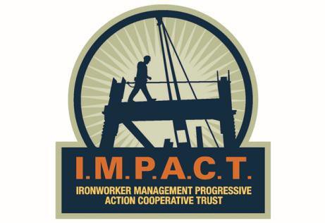

LEADERSHIP STRATEGIES FOR CONTRACTORS
CONTRACTOR COURSE

Sheraton Centre Toronto Hotel
Toronto, ON
December 10, 2015

APPLICATION FORM
Please print all information.

Applicant Information:
Name:

Position:

Phone: E-mail:

Company Name:

Phone: E-mail:

Contractor Signatory to Ironworkers Local .

Signature Date
NOTE: These courses fill up very quickly and applications will be accepted on a first come, first serve basis.

PH: (306-536-0442) or SCAN/E-MAIL this application and send it to:

Bert Royer (broyer@impact-net.org)

